Please print and completely fill out the following form to ensure timely processing. Credit card and address information is confidential. The completed form should be faxed to GWS.
ORDER BY |  | SHIP TO
Company |  | Company
Attn: |  | Attn:
Address |  | Address
City |  | City
Country |  | Country
Phone |  | Phone
Fax |  | Fax
E-mail |  | E-mail

Payment Information
Credit Card Type | VISA Master JCB
Credit Card Number
Expiration Date (MM/YYYY) |  |  |  |  |  |  |  |  | CCV2/CVC Number*
Card Holder’s Name
Credit Card Issuing Bank
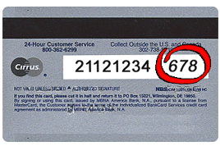

*Where Is My CCV2 or CVC Number: For Visa/ MasterCard cards, it is a three digit value printed in reverse italic characters on the signature panel following the last 4 digits of the account number.

Invoice Number |  | Currency | Amount | Notes
PHA-300 Upgrade and Handling |  | US Dollar | $35.00
Exchange Rate (US to NTD) | 33.64 | Grand Total NTD* | $1,177.00

*GWS will charge the exact amount as it shows above in grand total in NTD currency. Due to fluctuation of currency exchange rate, it may show slightly different exchange rate when you receive your credit card statement.

I , (Name of the card holder), authorize GWS to charge the above credit card for the grant total in NTD amount above for the purchase of GWS products and I absolutely and unconditionally guarantee payment for the purchases I made with the credit card account number identified above.

Signature of Card Holder Date

GWS USE ONLY
TEL : 0800-058-085, 0800-211-106, 2546-8588 FAX : 2545-3706, 2718-6764
Customer No. |  | Auth No.

